DIGITAL LITERACY

PROJECT REPORT
MEENAKSHI .L
25BSA10129
1st year
CSE0001

Overview of the Project
This project focused on building digital literacy and professional online skills through five structured tasks. Each module introduced practical aspects such as creating infographics, setting up a digital portfolio, exploring coding and collaboration platforms, drafting professional emails with etiquette, and researching cybercrime awareness. Together, these tasks helped strengthen technical abilities, communication skills, and responsible online behaviour.
Scenario
As a Digital Ambassador, the scenario placed me in the role of guiding peers toward safe, effective, and professional use of digital tools. From learning how to present ourselves online to understanding threats like phishing and cyberbullying, the project emphasized both opportunities and risks in the digital world. The overall aim was to prepare students to be smart, safe, and responsible digital citizens, ready for academic and professional challenges.

Task 1: Digital Literacy Infographic

For this task, I chose Canva as my design tool because of its wide range of templates and user-friendly interface. My infographic highlights five key aspects of digital literacy: understanding what digital literacy is, useful digital tools for students, safe internet practices, professional online presence, email etiquette. Each section is represented with icons and short bullet points to make the information clear and visually appealing. For example, I included tools like Google Drive and Trello, tips for creating strong passwords, and reminders to use polite greetings in emails. The colour scheme combines blue and green to convey trust and growth, while orange accents add energy.
One interesting part of the process was realizing how much design choices affect communication. Balancing visuals with concise text was challenging, but it taught me that effective digital literacy awareness depends not only on the information shared but also on how it is presented. This made the task both creative and insightful.
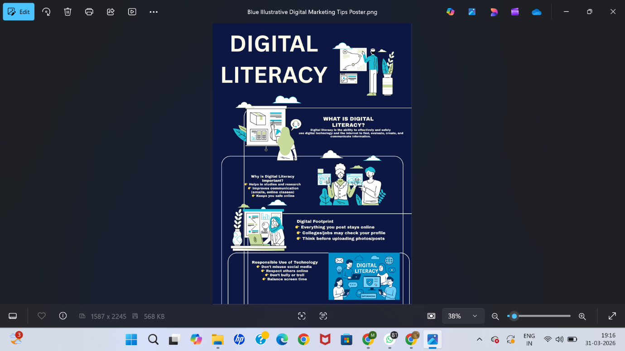

Task 2: Build Your Student Digital Portfolio
For this task, I built my digital portfolio on GitHub, LinkedIn, and Kaggle. On GitHub, I created a profile README that includes my name, branch, year, and a short statement about my learning goals. This platform will serve as a showcase for my coding projects and collaborative work. On LinkedIn, I updated my Education section with my current degree, institution, and expected graduation year. LinkedIn will help me connect with peers, faculty, and potential employers while presenting my academic and professional achievements. On Kaggle, I set up a profile to explore datasets and participate in competitions, which will strengthen my skills in data analysis and machine learning.
I found it interesting to see how each platform highlights different aspects of professional growth. Together, they provide a strong foundation for my digital identity, which I plan to expand over the next four years with projects, research, and networking.

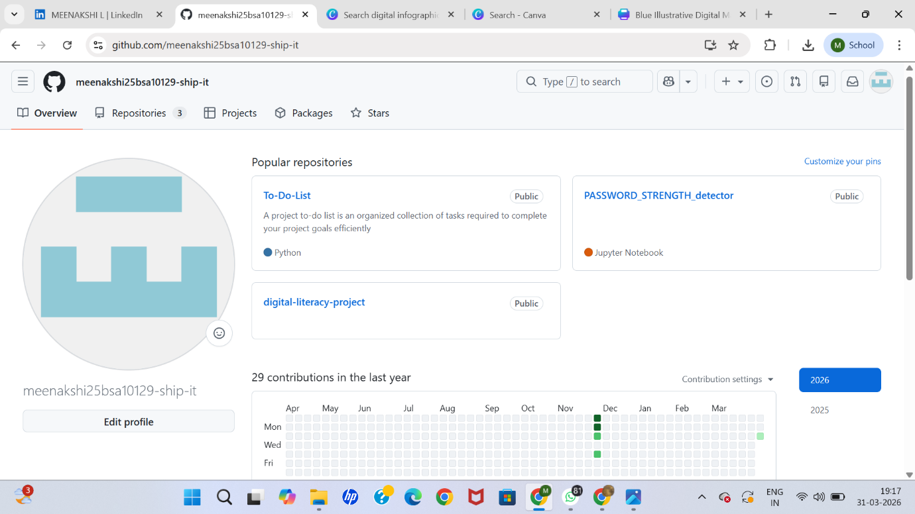

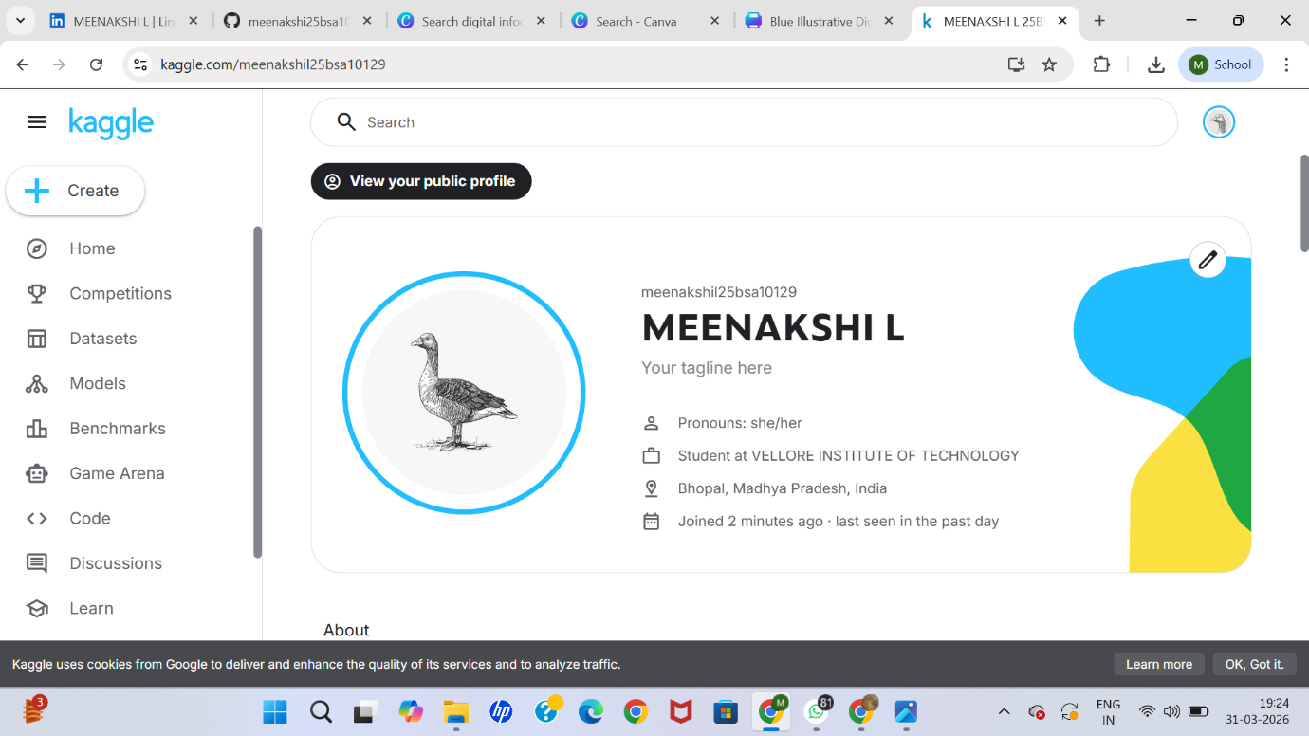
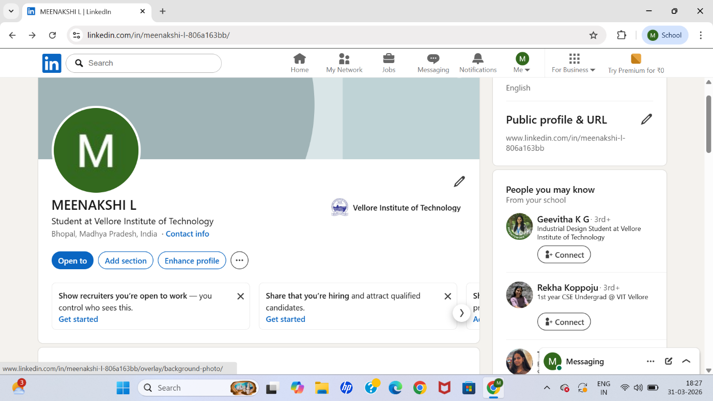

Task 3: Explore Coding & Collaboration Platforms
PART-1
HackerRank
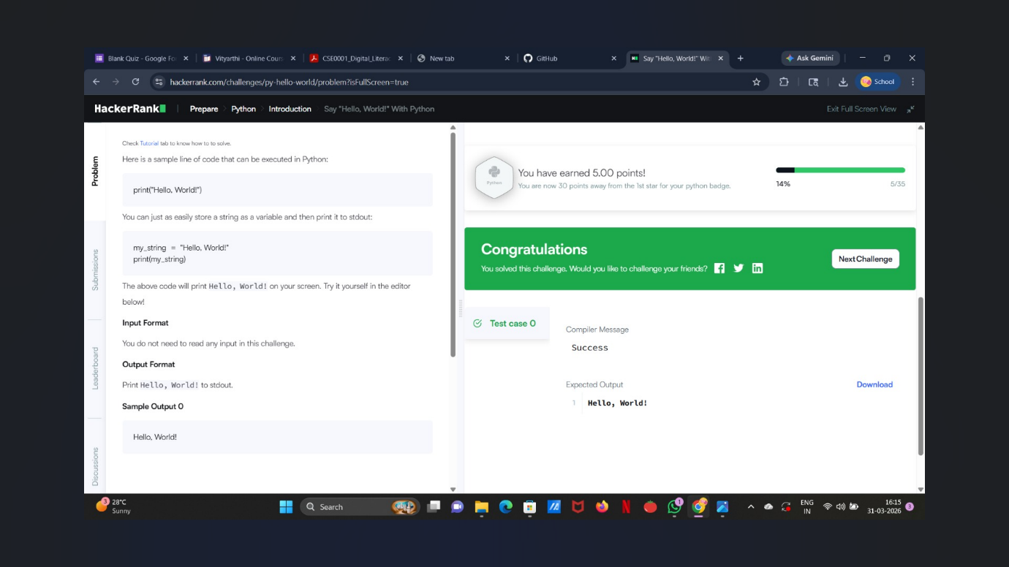
PART-2
https://docs.google.com/forms/d/e/1FAIpQLScsROoWmYMxSZeK2NQ7gOZTRYGKmrwRb_UPquaItdjUuTgXag/viewform?usp=publish-editor
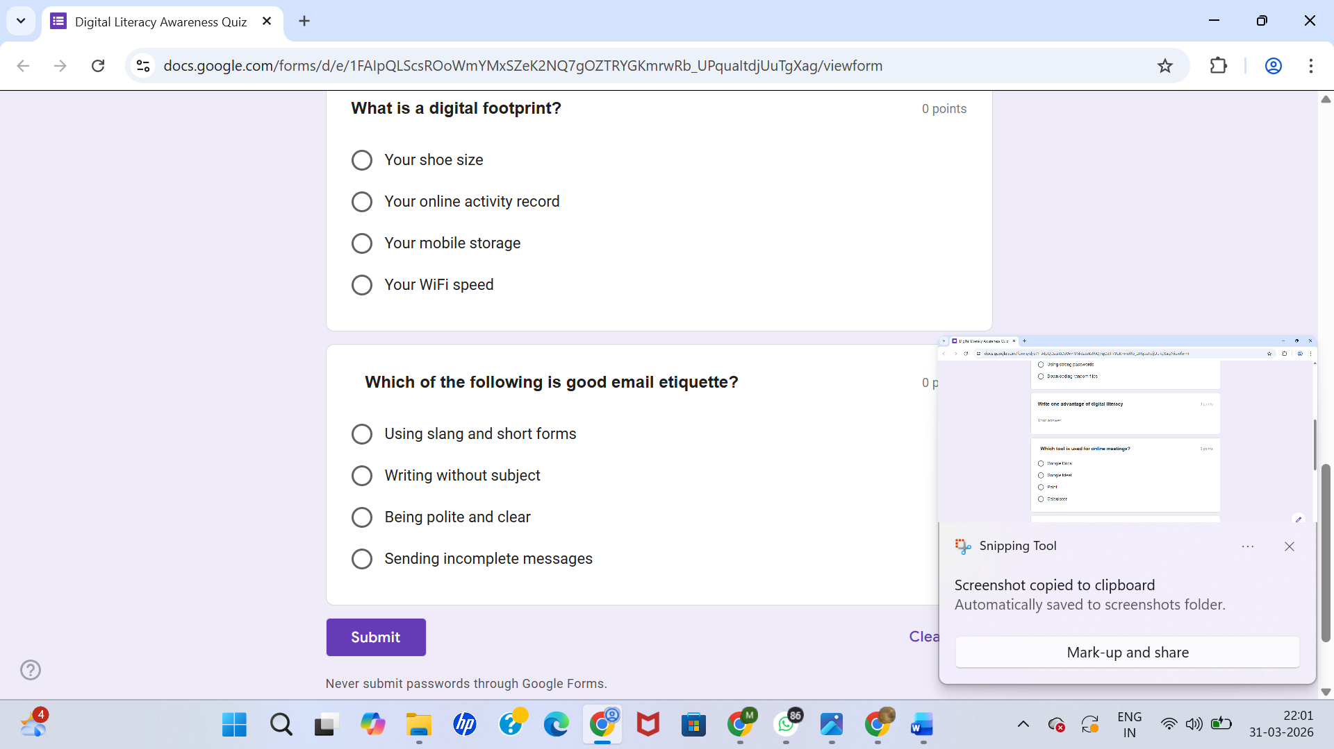
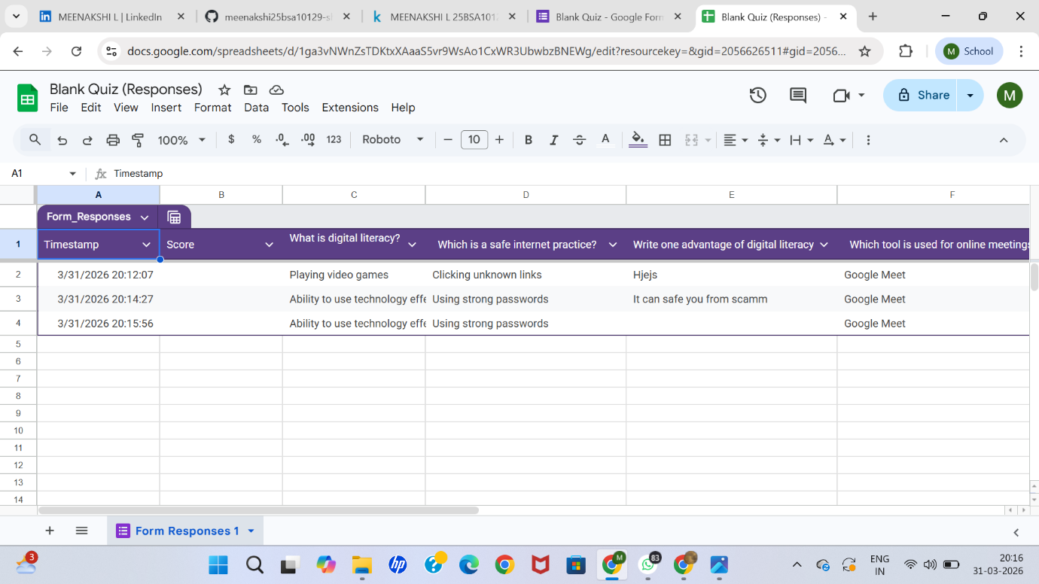

For this task, I worked with HackerRank and Google Workspace. On HackerRank, I created an account and completed the beginner challenge “Solve Me First.” This exercise introduced me to the coding environment and helped me practice problem-solving with instant feedback. I found the scoring and badges motivating, as they encourage consistent learning and improvement in programming skills.
For the collaboration part, I designed a Google Form with five questions for a Digital Literacy Awareness Quiz, including multiple choice and short answer formats. I linked the form to a Google Sheet, which allowed me to view responses in real time. This demonstrated how Google Workspace tools can simplify surveys, feedback collection, and group projects.
Overall, these platforms will support my academic journey by strengthening my coding abilities and enhancing collaboration with peers, making teamwork and learning more efficient.

Project Report – Task 4: Professional Email & Etiquette Guide
Part A: Two professional emails
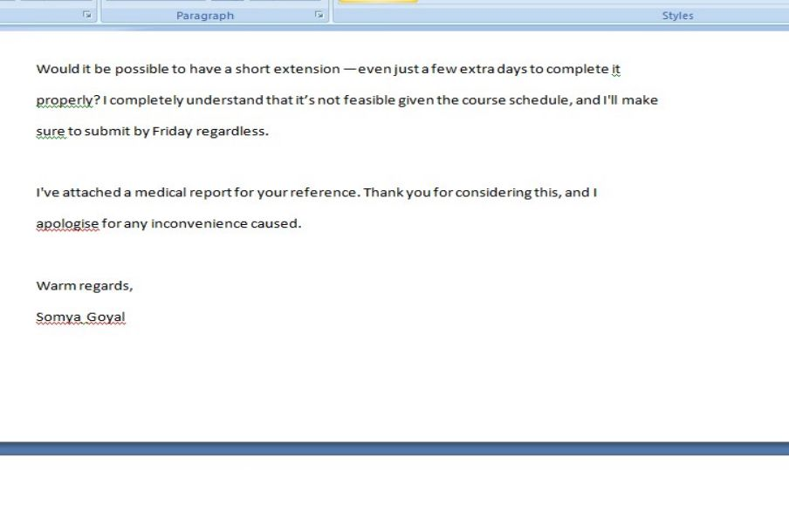
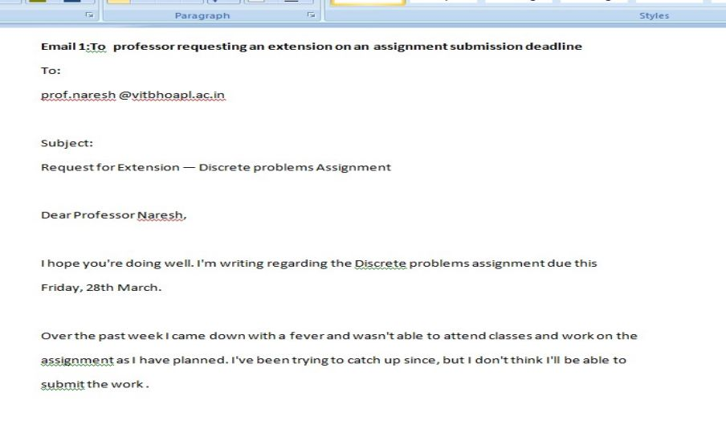

Part B: Social Media Do's and Don'ts checklist
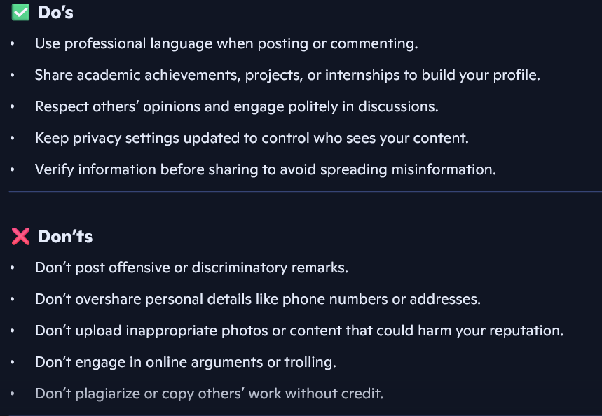

Poor digital communication can easily create misunderstandings and damage professional relationships. For example, I once read about a student who emailed a professor using casual language, no subject line, and incomplete details when requesting an extension. The professor found the email unclear and unprofessional, which led to the request being denied. This situation highlights how failing to follow email etiquette—such as using a proper greeting, clear subject, and respectful tone—can negatively affect outcomes.
What could have been done differently was simple: the student should have written a structured email with a clear subject line, explained the reason for the extension politely, and ended with a professional closing. By applying proper etiquette, the message would have been taken seriously, and the student’s chances of receiving a positive response would have been much higher.

TASK-5 Cybercrime Awareness Case Study & Prevention Guide
Part A:Case Study
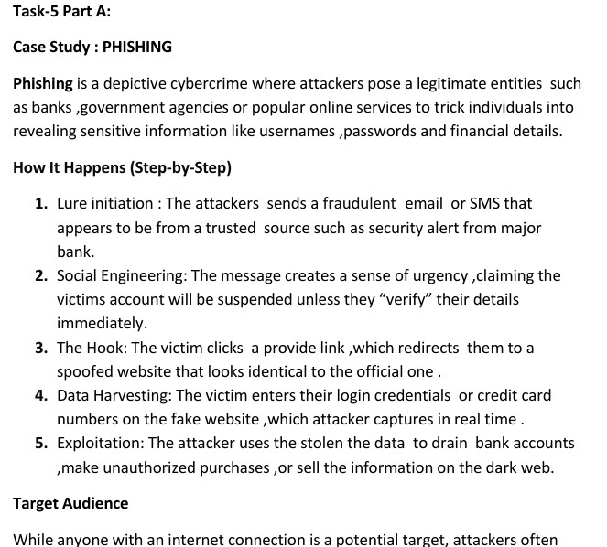
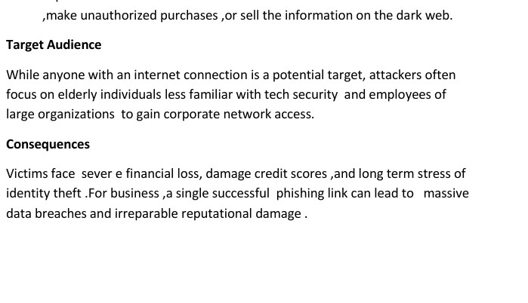
Part B: Prevention Checklist
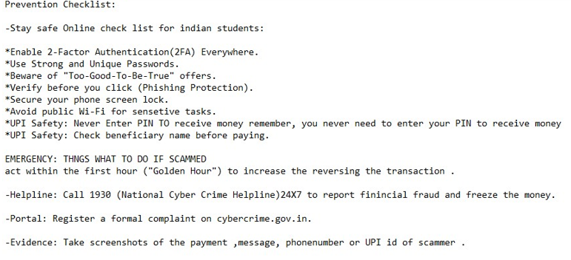

While researching phishing, I was most surprised by how convincing fake emails and websites can look. Attackers often copy logos and language so well that even cautious students may fall for them. I realized that small details, like checking the sender’s address or URL spelling, can make a huge difference in spotting fraud. Personally, one habit I will change is clicking links directly from emails. Instead, I will always type the official website address myself or use bookmarked links. This simple step reduces the risk of being redirected to a fake page. The research taught me that cybercrime prevention is less about advanced tools and more about consistent safe practices.

Conclusion
Through this project, I gained a deeper understanding of digital literacy, professional communication, collaboration tools, and cybercrime awareness. Each task—from designing infographics and building a digital portfolio to exploring coding platforms, drafting professional emails, and researching cybercrime—helped me connect theory with practical skills. I learned how important it is to maintain a professional online presence, practice safe internet habits, and use digital tools responsibly. The case study on phishing especially highlighted the risks of careless online behaviour and the need for vigilance. Overall, this project has not only improved my technical and communication skills but also shaped my digital identity as a student. Moving forward, I will apply these lessons to academic work, internships, and professional networking, ensuring that I remain smart, safe, and responsible in the digital world.

References
- Google Chrome
- HackerRank
- Copilot
- Chatgpt
- Canva
- Git hub
- Kaggle

THANK YOU

